Original Article

Title of the article: If your final manuscript has 15 pages or more

Author A1,2*, Author B1, Author C1 and Author D2

1Departement of E, Faculty of F, Universitas F, Bali, Indonesia; 2Departement of G, ABC Hospital, Jakarta, Indonesia

*Corresponding author: [authoremail@email.com](mailto:authoremail@email.com)

Abstract

A concise non-structured abstract is required. The abstract should state briefly the purpose of the research, the principal results and major conclusions. Abstract must be able to stand alone. References should be avoided. Non-standard or uncommon abbreviations should be avoided, but if essential they must be defined at their first mention in the abstract itself. Five key words should be listed after the abstract. Keywords should be self-sufficient to allow the classification of the paper by subject area and to function as heads in a volume’s index of keywords. Choose them according to Index Medicus, do not merely duplicate words from the title.

**Keywords**: Keyword 1, keyword 2, keyword 3, keyword 4, keyword 5

Introduction

State the objectives of the work and provide an adequate background, avoiding a detailed literature survey or a summary of the results.

Lorem ipsum dolor sit amet, consectetur adipisicing elit, sed do eiusmod tempor incididunt ut labore et dolore magna aliqua. Ut enim ad minim veniam, quis nostrud exercitation ullamco laboris nisi ut aliquip ex ea commodo consequat. Duis aute irure dolor in reprehenderit in voluptate velit esse cillum dolore eu fugiat nulla pariatur. Excepteur sint occaecat cupidatat non proident, sunt in culpa qui officia deserunt mollit anim id est laborum [1].

Methods

Please provide sufficient detail to allow the work to be reproduced. If the study using a reagent, details of supplier should be provided when appropriate. Methods already published should be indicated by a reference and only relevant modifications should be described. For epidemiology, details of setting, time and place should be provided.

Method section 1

Lorem ipsum dolor sit amet, consectetur adipisicing elit, sed do eiusmod tempor incididunt ut labore et dolore magna aliqua. Ut enim ad minim veniam, quis nostrud exercitation ullamco laboris nisi ut aliquip ex ea commodo consequat. Lorem ipsum dolor sit amet, consectetur adipisicing elit, sed do eiusmod tempor incididunt ut labore et dolore magna aliqua. Ut enim ad minim veniam, quis nostrud exercitation ullamco laboris nisi ut aliquip ex ea commodo consequat [1, 2].

Method section 2

Lorem ipsum dolor sit amet, consectetur adipisicing elit, sed do eiusmod tempor incididunt ut labore et dolore magna aliqua. Ut enim ad minim veniam, quis nostrud exercitation ullamco laboris nisi ut aliquip ex ea commodo consequat. Duis aute irure dolor in reprehenderit in voluptate velit esse cillum dolore eu fugiat nulla pariatur. Excepteur sint occaecat cupidatat non proident, sunt in culpa qui officia deserunt mollit anim id est laborum [1].

Results

Results should be clear and concise. Tables and figures are preferred.

Result 1 about figures

All figures should use Arial font and all figures should be created in high quality (**Figure 1**). All figures should use Arial font and all figures should be created in high quality. If the figures are created in Microsoft Office application (Word, PowerPoint, Excel) then please supply 'as is' in the native document format and placed in the end of the manuscript after tables. If the figures are created using a non-Microsoft Office program, the figure should be converted as images in TIFF or JPEG at a minimum of 300 dpi. Narra J Editor has right to request authors to revise the figures if required.

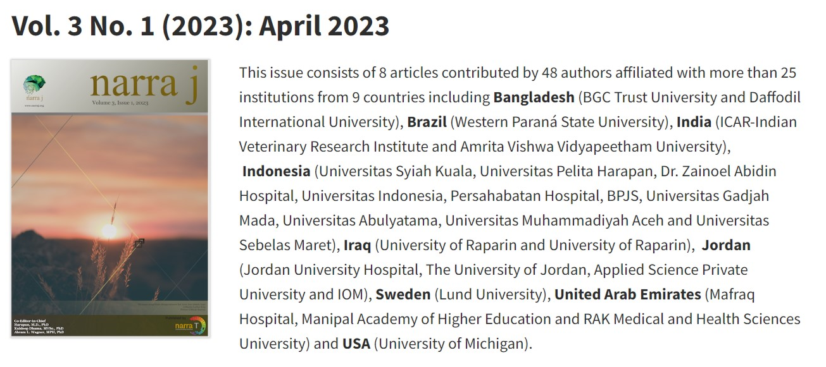

Figure 1. Cover of Narra J Vol. 3 No. 1 (2023) and affiliations of the contributing authors.

Result 2 about table format

Tables should be submitted as editable text and not as images and should be placed on separate page(s) at the end. Tables should be submitted as editable text and not as images and should be placed on separate page(s) at the end. Number tables consecutively in accordance with their appearance in the text and place any table notes below the table body. Please ensure that the data presented tables do not duplicate results described elsewhere in the article. Please avoid using vertical rules and shading in table cells. A sample of table is presented in **Table 1**.

Table 1. Table title

|  |  |  |
| --- | --- | --- |
| Sample | Value ((± SD) | *p*-value |
| ABC | 2,375 ± 3.25 | 0.123a,* |
| DEF | 2,375 ± 3.25 | 0.123b |
| GHI | 2,375 ± 3.25 | 0.123a |
| JKL | 2,375 ± 3.25 | 0.123b,* |

a Analyzed using Mann-Whitney test

b Analyzed using Student *t*-test

*Statistically significant at *p*=0.05

Discussion

This section discusses the significance of the results of the study. Please avoid extensive citations and discussion of published literature, rather explain discussion of the explanation of the results.

Conclusion

The main conclusions of the study should be stated briefly based on the results of the study. Please avoid to cite the previous study.

Ethics approval

The Ethical approval statement should be provided including the consent. If not appropriate, authors should state: *“Not required.”*

Acknowledgments

Acknowledgements should be placed at the end of the article before the references. List here those individuals who provided help during the research such as providing language help, writing assistance or proof reading the article and others.

Competing interests

A competing interest statement should be provided, even if the authors have no competing interests to declare. If no conflict exists, authors should state: *“All the authors declare that there are no conflicts of interest.”*

Funding

List funding sources in this standard way to facilitate compliance to funder's requirements. It is not necessary to include detailed descriptions on the program or type of grants and awards. When funding is from a block grant or other resources available to a university, college, or other research institution, submit the name of the institute or organization that provided the funding. If no funding has been provided for the research, please include the following sentence: *“This study received no external funding.”*

Underlying data

This can be written as: “*Derived data supporting the findings of this study are available from the corresponding author on request*.”

Declaration of artificial intelligence use

If authors used the AI during the study or manuscript preparation, please add the statements (chose one or more the alternative) and add compulsory statement.   
  
*“This study used artificial intelligence (AI) tools and methodologies in the following capacities* (**CHOOSE & EDIT AS APPROPRIATE**):

1. **Data analysis and modeling**: Machine learning algorithms, including [specific algorithms or techniques], were used to analyze the dataset and predict outcomes. These were implemented using [software/tools, e.g., Python, Scikit-learn, TensorFlow].
2. **Data preprocessing**: AI-assisted techniques [state the technique(es)] were/was applied for data cleaning, feature selection, and transformation to prepare the dataset for analysis.
3. **Visualization**: AI tools, such as [e.g., Tableau, Matplotlib with AI extensions], were/was used for generating graphs, charts, and visual summaries.
4. **Manuscript writing support**: AI-based language models, such as [e.g., ChatGPT, Quillbot], were/was employed to (**CHOOSE AS APPROPRIATE**):
   1. Language refinement (improving grammar, sentence structure, and readability of the manuscript).
   2. Content summarization (assisting in summarizing findings and conclusions in a concise manner).
   3. Technical writing assistance (providing suggestions for structuring complex technical descriptions more effectively)
   4. Generate scientific content, interpret data, and draw conclusions
5. **Simulation and forecasting**: Predictive modelling and simulations were conducted using AI frameworks to validate research hypotheses.

**PLUS**

*“We confirm that all AI-assisted processes were critically reviewed by the authors to ensure the integrity and reliability of the results. The final decisions and interpretations presented in this article were solely made by the authors.”*  
  
This declaration does not apply to the use of basic tools for checking grammar and spelling (such Grammarly), references (EndNote, Zotero, etc), SPSS.

If there is nothing to disclose:   
  
*We hereby confirm that no artificial intelligence (AI) tools or methodologies were utilized at any stage of this study, including during data collection, analysis, visualization, or manuscript preparation. All work presented in this study was conducted manually by the authors without the assistance of AI-based tools or systems.*

How to cite

Author 1, Author 2, Author 3, *et al*. Title of original article. Narra J 2025; 5 (X): e[X] - [http://doi.org/10.52225/narra.v5i[X].[X]](http://doi.org/10.52225/narra.v5i%5bX%5d.%5bX%5d).

References

1. Goddard M, Smith P. Equity of access to health care services: Theory and evidence from the UK. Soc Sci Med 2001;53(9):1149-1162.

2. Koji H, Tetsuya O, Susumu K*, et al*. Examining sufficiency and equity in the geographic distribution of physicians in Japan: a longitudinal study. BMJ Open 2017;7(3):e013922.

3. Lankila T, Laatikainen T, Wikström K*, et al*. Association of travel time with mental health service use in primary health care according to contact type - a register-based study in Kainuu, Finland. BMC Health Serv Res 2022;22(1):1458.

4. Paniz VMV, Fassa AG, Maia MdFS*, et al*. Measuring access to medicines: a review of quantitative methods used in household surveys. BMC Health Serv Res 2010;10(1):146.

5. Omrani-Khoo H, Lotfi F, Safari H*, et al*. Equity in distribution of health care resources: Assessment of need and access, using three practical indicators. Iran J Public Health 2013;42(11):1299-1308.