How to use Mendeley Desktop with a link

Copy the link: https://csl.mendeley.com/styles/709123921/narra-sains-narra-j-editor-s01-2

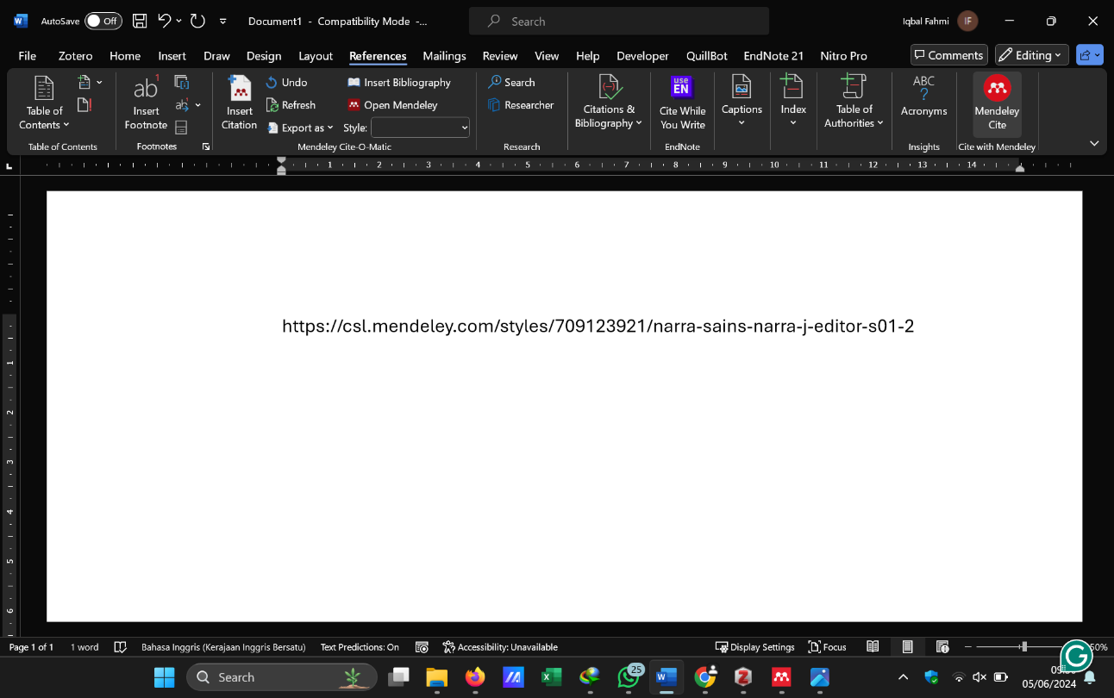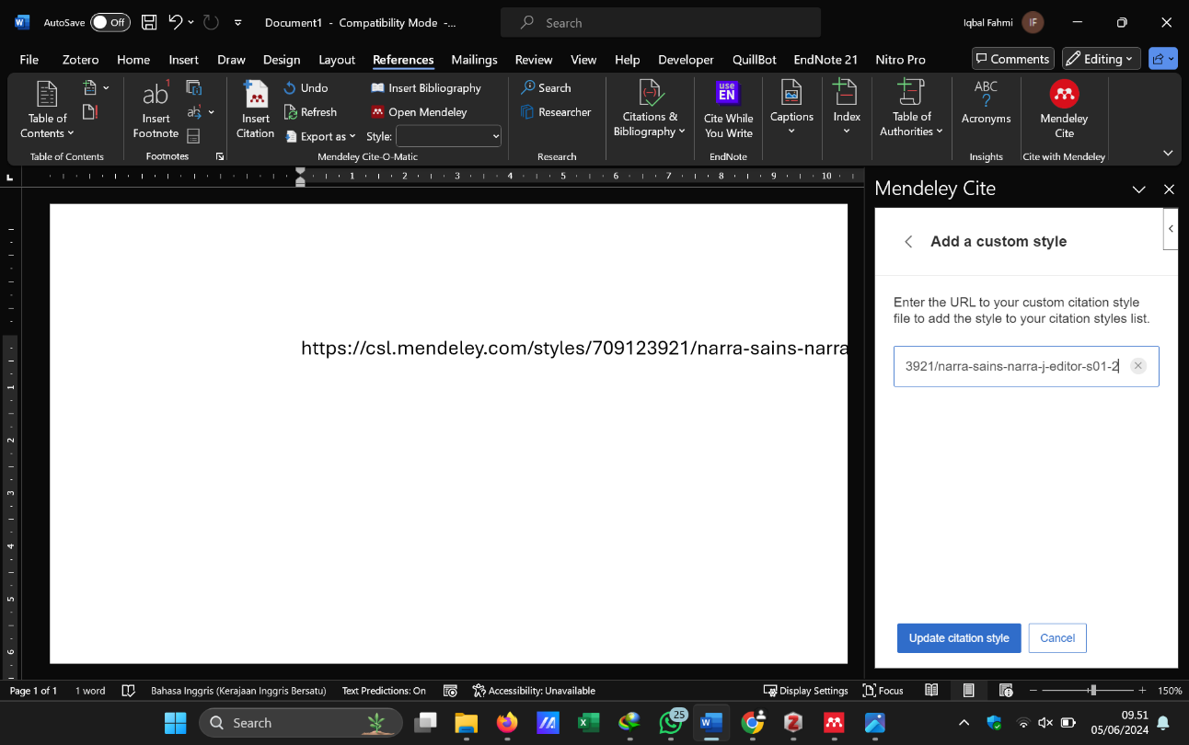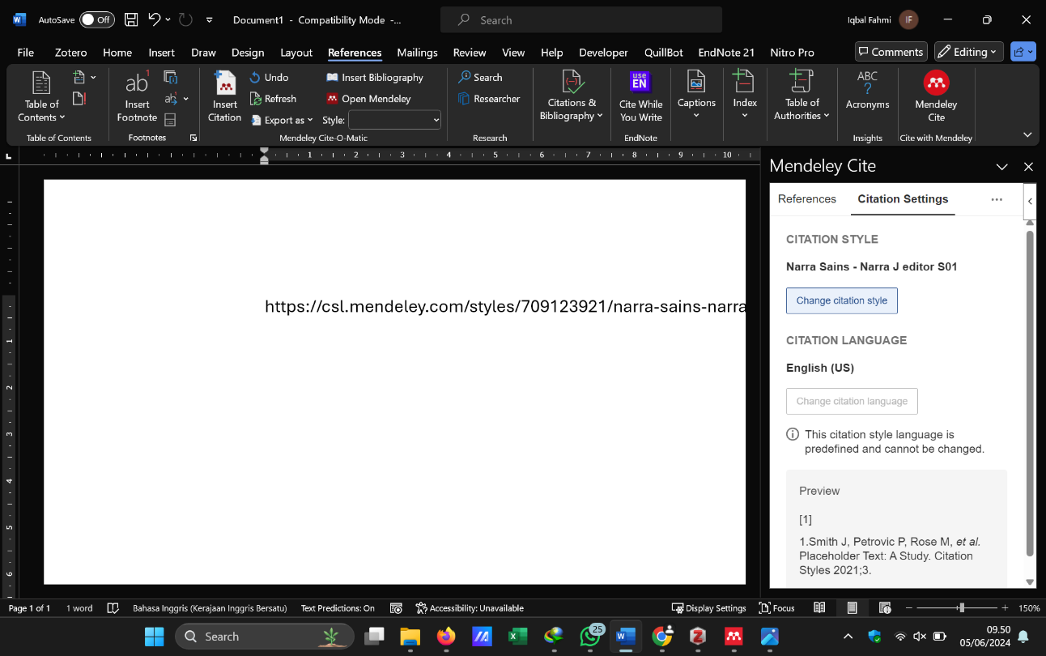

Scroll down